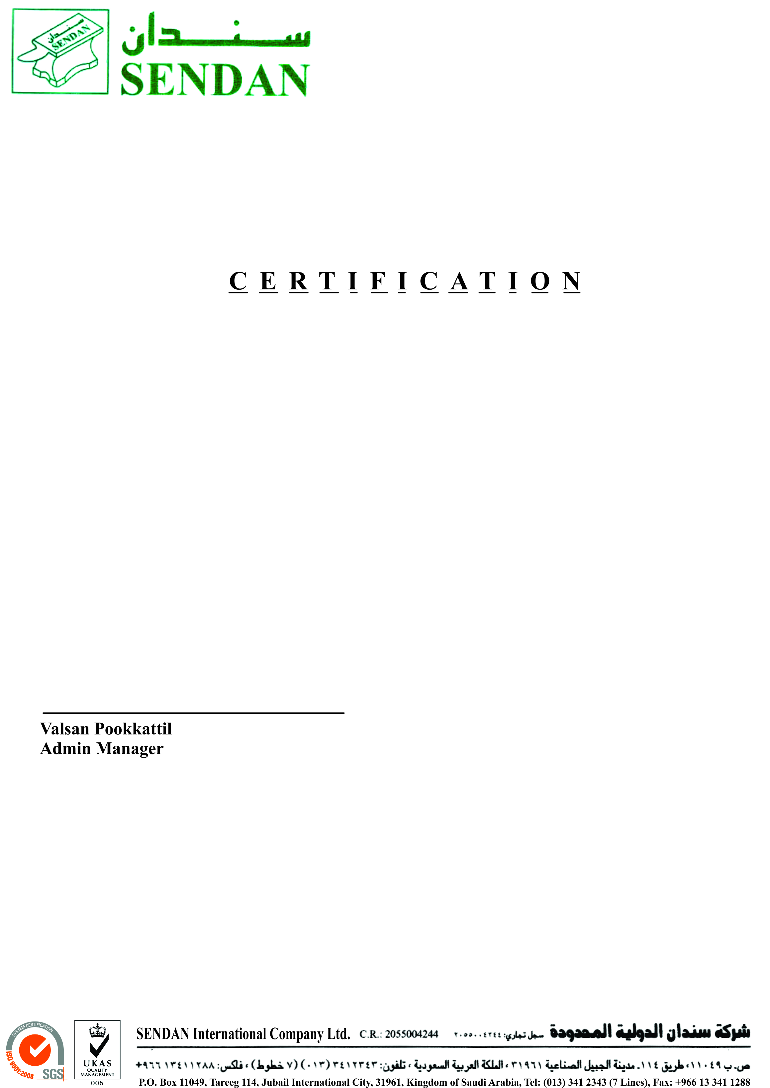

**TO WHOM IT MAY CONCERN:**

This is to certify that Mr. <Name> as Pakistani National holding Passport No. <Passport> was our employee since <From2> to <To2>. He served the company as <Designation>.

This Certificate has been issued upon the request of Mr. M. Ihsan for what ever purpose it may

serve him.

